DISPRO 3D PORTABLE MAGICAL EDUTAINMENT SYSTEM. Sept’2020
We are very proud of our great country India, having over 25 crores students (more than populations of Japan, Taiwan & South Korea put together) deserve 'the Best" in education to grow as national asset. We are pleased to offer world's first 3D Edutainment systems, with 3D stereoscopic content, large 3D projection system with 3D silver screen & 3D glasses. 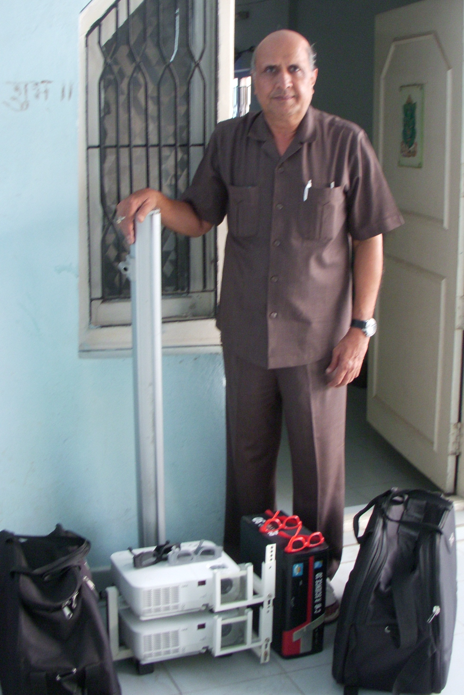
We have designed and made very unique multi purpose portable 3D stereo projection set for 3D passive projection. We proudly launched first time in April 2009.This unique 3D projection set up is for marketing, education, presentation, religious places and home entertainment. This can be easily horizontally/vertically aligned for best 3D projection.
Basic set is suitable for our Indian children to fully enjoy 3D edutainment in schools, villages, remote areas. This portable system has provided unemployed youths to start all new successful low cost edutainment business. Already many have been benefitted in various locations. This highly successful system is easy to carry in 2 bags , provided with polarizing glasses, stereo CPU and tripod 3D silver screen etc.
We have 3D contents in 3 different ways:-
1.Worldwide 3D movies appear behind the screen.
2.Many 3D advt. & video appear on the screen.
3.Exclusive 3D contents appear coming out of screen like our Smart Kids 3D edutainment.
Our portable 3D system can be useful for high quality marketing, demo and presentation purposes. Being customized, we can use different projectors with this set to meet different requirements.
Our very unique Large Screen 100” 3D RPTV
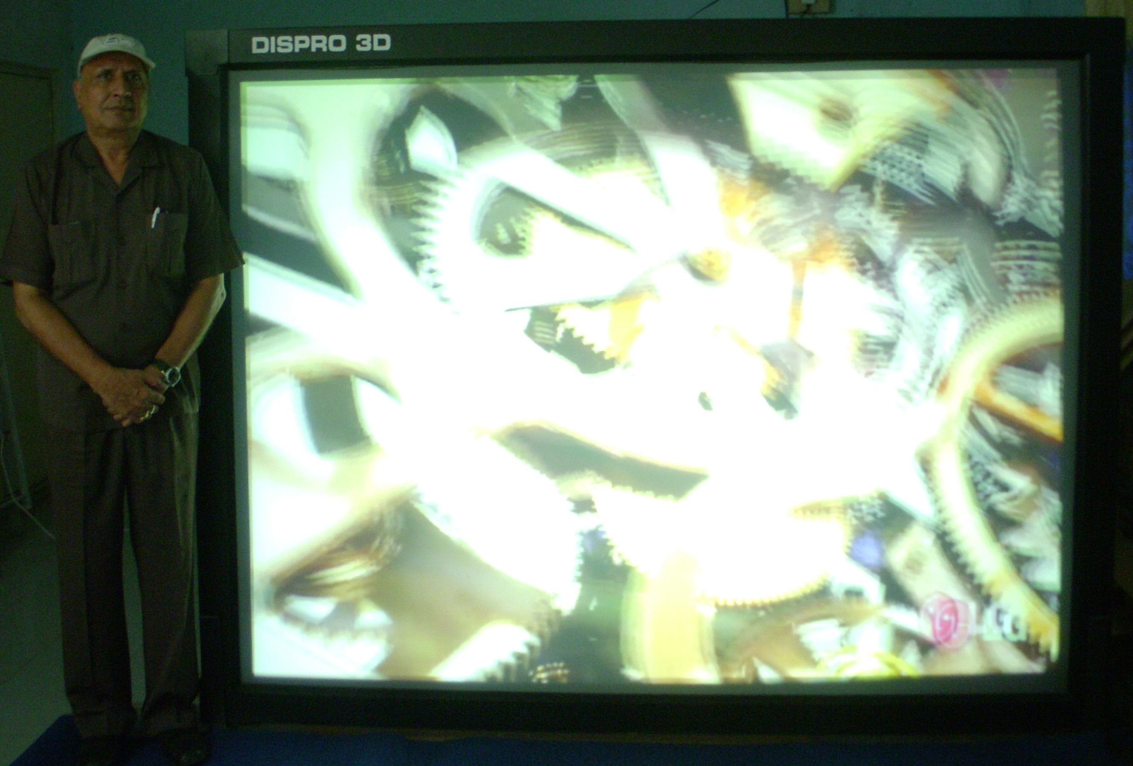
Our portable 3D projection system can be used with our very high quality rigid optical rear projection INTENSAA screens 80”,100” diagonal for various purposes like education, home & club entertainments, large data ,marketing displays, video conferencing, simulation etc.
DISPRO VISUAL TECHNOLOGIES LTD., DISPRO HOUSE, 48-322 Ganesh Nagar, Chintal HYDERABAD-500054 Ph: 040-23080450

